Real Estate Investment Project Plan: Family Company in Macomb, Michigan

1. Overview
- Project: Purchase and management of a single-family 2 bed / 2 bath house in Macomb, Michigan.
- Total Budget: $250,000
- Down Payment: $50,000 (cash contribution from founders)
- Financing: $200,000 via 30-year mortgage at 7% interest rate
- Founders: Two brothers
  - Brother 1: U.S. Green Card holder
  - Brother 2: TN Visa holder (cannot earn income outside TN-approved employment)
- Goal: Create a legally compliant structure allowing Brother 2 to live in the property while enabling tax-efficient, long-term wealth preservation and income.

2. Entity Structure Recommendation
- Legal Entity: LLC (Limited Liability Company)
  - Why?
    - Pass-through taxation for simplicity
    - Allows flexible profit sharing
    - Better suited to hold real estate than S-Corp
    - Easier compliance with TN Visa restrictions (Brother 2 can be a member but cannot actively manage or be employed)
- Ownership:
  - Equal 50/50 ownership with contributions documented in Operating Agreement
  - Brother 2's use of the property structured as either:
    - Rental agreement: Market-rate lease, to meet arms-length and IRS fair-market-value standards
    - Lease-to-own or purchase option: Clearly documented option contract

3. Legal & Administrative Requirements
- LLC Formation in Michigan:
  - File Articles of Organization with Michigan LARA ($50 fee)
  - Obtain EIN from IRS
  - Draft Operating Agreement (important for structuring rights)
  - Register for local business license if required
- Mortgage Considerations:
  - Lender must allow LLC borrower (some may require personal guarantees)
  - Likely higher interest rate for LLC-held mortgages

4. Investment Pro Forma (Year 1 Highlights)
Category | Value ($)
Rental Income (Year 1) | 21,600
Mortgage Payments | -15,955
Property Taxes | -4,050
Maintenance | -2,500
Insurance | -1,200
Management Fees | -1,296
Net Operating Income | -3,401
Depreciation (Non-Cash) | -9,090
Taxable Income | -12,491
Estimated Taxes | 0
Cash Flow to Firm | 1,644
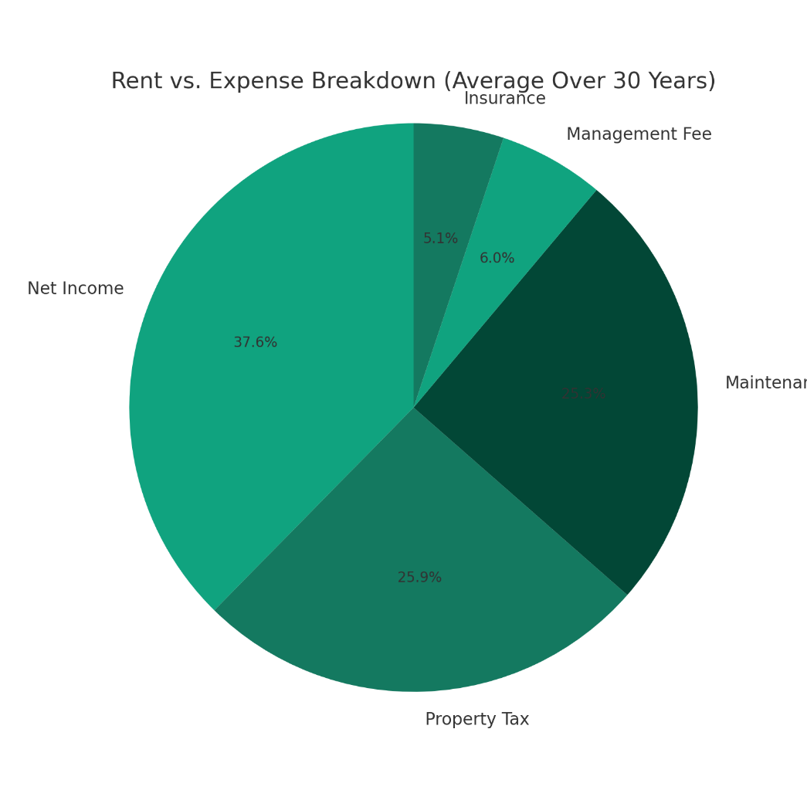
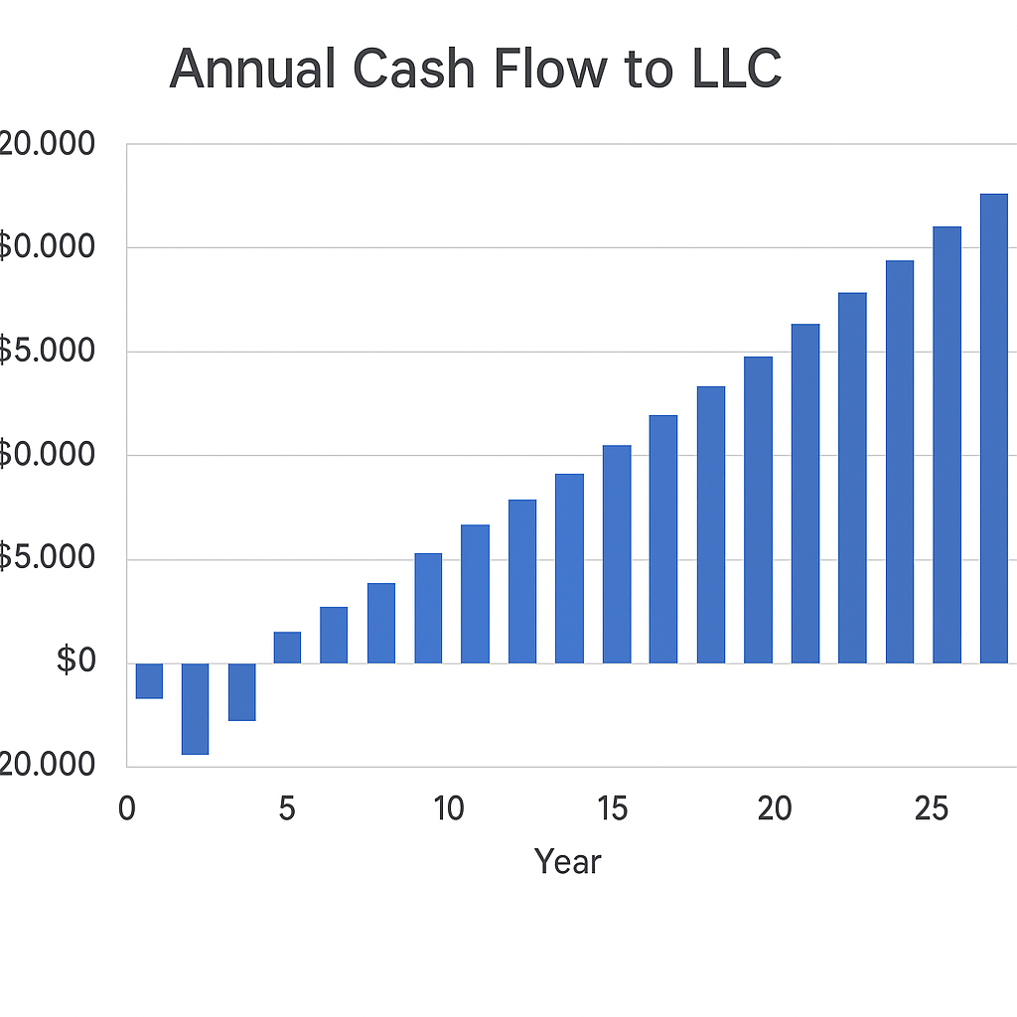

5. Financial Metrics (30-Year Projection)
- NPV (at 7% discount rate): +$69,000
- IRR: 9.5%
- WACC:
  - Equity: $50,000 at 10% cost
  - Debt: $200,000 at 7% cost, 21% tax shield
  - WACC = 7.2%
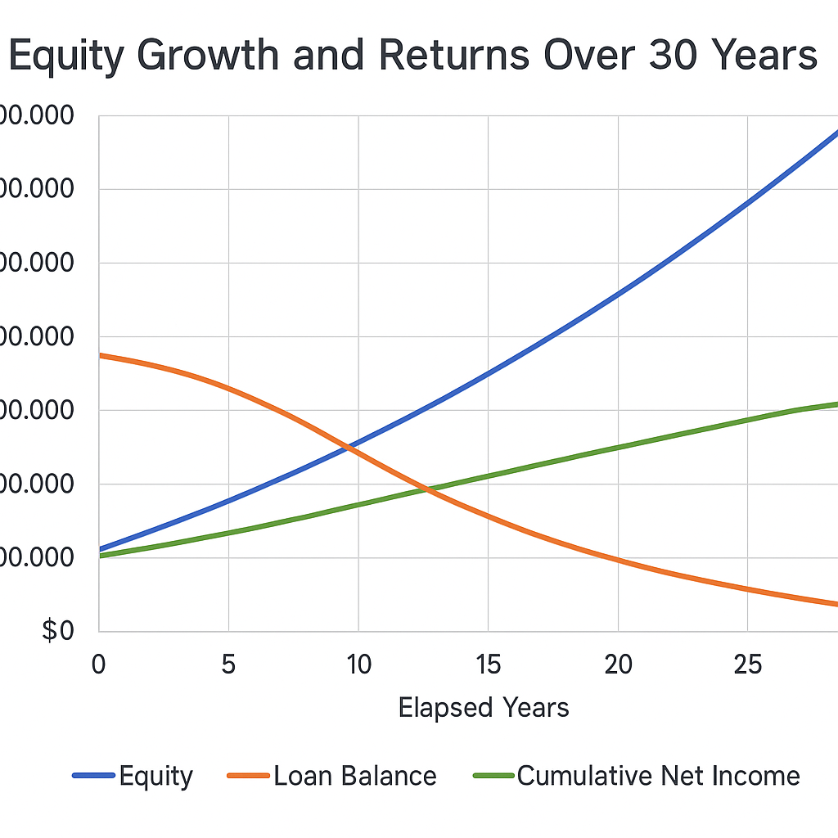
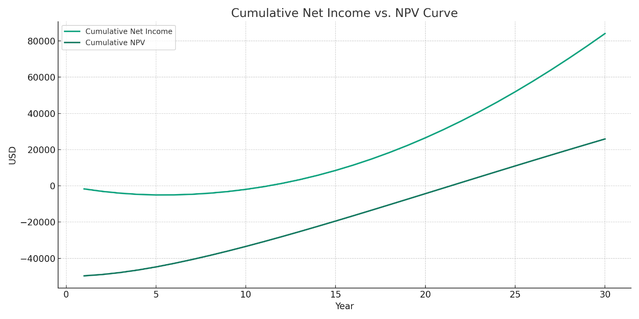

6. Strategic Benefits
- Property held in company provides:
  - Legal liability shield
  - Future rental or resale flexibility
  - Possible appreciation (4.67% avg.)
- Allows one brother to live in property while both build equity
- Preserves long-term family ownership across generations

7. Next Steps
- Form LLC with defined Operating Agreement
- Consult CPA to confirm TN Visa compliance
- Secure pre-approval for LLC mortgage
- Draft lease or purchase option agreement for Brother 2
- Proceed with property acquisition

Note: Final structure should be reviewed by an immigration attorney (for TN Visa limitations) and a CPA/lawyer (for tax structuring).

Sample Operating Agreement Clauses (LLC for Real Estate)
1. Ownership Structure
“The Company is jointly owned by [Your Full Name] and [Brother’s Full Name], each holding a 50% membership interest.”
2. Capital Contributions
“Initial contributions shall be $25,000 from each member, forming a total capital base of $50,000. Additional contributions may be made pro rata.”
3. Management Structure
“The LLC shall be managed by [Your Name], Member-Manager. [Brother’s Name] shall be a passive member in compliance with TN Visa requirements.”
4. Use of Property
“The property owned by the LLC may be leased to a member, provided that rent reflects fair market value and is documented by a lease agreement.”
5. Distribution of Profits
“Profits shall be distributed in proportion to capital contributions, or as otherwise agreed by all members in writing.”
6. Buy-Sell / Exit Option
“In case of withdrawal, death, or incapacitation, the other member shall have right of first refusal to buy out the member’s interest.”

📃 Lease-to-Own Agreement Terms (Sample)
1. Lease Terms
- Lessee: [Brother's Full Name]
- Monthly Rent: $1,800/month, subject to 3% annual increase
- Lease Term: 5 years renewable
2. Purchase Option
- Lessee may exercise option to purchase property after Year 5
- Option Price = Market Value at time of exercise, less accumulated rent credited (e.g., $300/month credited toward price)
3. Maintenance & Repairs
- Lessee responsible for utilities and minor repairs < $500
- LLC handles taxes, insurance, and major structural issues
4. Legal Note
- This option must be non-compulsory and separate from the lease to avoid IRS recharacterization as an installment sale.

